Retrieval-Augmented Generation for Biomedical Yes/No Reasoning: A Comparative Study of Three Lightweight Language Models.

Abstract
Retrieval-Augmented Generation (RAG) combines external document retrieval with generative language models to improve factual accuracy, interpretability, and robustness. In this work, we develop a full RAG pipeline for PubMedQA and compare three lightweight LLMs – Flan, T5-Small, and Bloomz-560M. We evaluate accuracy, precision, recall, and reasoning quality. Our results show that small models struggle but Flan-T5 performs best overall due to instruction tuning.

Introduction
Large language models have strong general abilities but often struggle with specialized biomedical knowledge. Retrieval-Augmented Generation (RAG) helps address this by grounding model outputs in external scientific evidence. In this project, we build a complete RAG pipeline tailored to the PubMedQA dataset. We evaluate three lightweight LLMs - Flan, T5-Small, and Bloomz-560M on biomedical yes/no reasoning tasks.

Related Work and System Overview
Prior work in Retrieval-Augmented Generation (RAG) demonstrates that combining external knowledge sources with language models improves factual grounding and reduces hallucinations. Instruction-tuned models such as Flan-T5 excel at following task-specific prompts, while multilingual models like Bloomz extend capabilities across languages. Biomedical QA datasets, including PubMedQA, provide benchmarks for evaluating evidence-based reasoning in specialized domains. Building on these insights, our RAG pipeline includes:
- Document chunking of PubMed abstracts
- Embedding generation using MiniLM embeddings and FAISS indexing
- Top 5 relevant chunk retrieval and
- Answer generation by LLMs using structured prompts to integrate retrieved evidence effectively.
This design allows small models to leverage external knowledge and produce more accurate, context-aware responses.

Dataset
The dataset for this project is the PubMedQA labeled set, which contains 1,000 biomedical yes/no questions paired with expert-written rationales and supporting PubMed abstracts. Each example includes a clinical or biomedical research question, a short-context summary, and a ground-truth “yes,” “no,” or “maybe” answer. We apply an 80/20 stratified split to preserve the distribution of answer labels across training and evaluation. All abstracts are cleaned, lowercased, and segmented into overlapping text chunks to support retrieval. The dataset is well-suited for testing factual reasoning because many questions require integrating study outcomes, experiment details, or clinical trial evidence. This makes PubMedQA an ideal benchmark for evaluating RAG effectiveness and small-model reasoning quality.

Domain-Specific Questions
To evaluate model robustness beyond the PubMedQA dataset, we curated 10 expert-level biomedical reasoning questions spanning diverse medical domains. These questions were designed to mimic real clinical inquiry, requiring evidence-based reasoning rather than memorization. The set includes topics from cardiology, endocrinology, oncology, neurology, infectious diseases, and pharmacology, ensuring broad coverage of biomedical knowledge. Each question was validated using PubMed literature to ensure that a correct yes/no answer could be grounded in evidence. The questions emphasize causal reasoning, treatment efficacy, biomarker interpretation, and drug–disease interactions. By introducing challenging, real-world queries, we assessed how well small LLMs generalize under RAG conditions and whether retrieval meaningfully boosts factual accuracy. Some of the questions are listed below
- Does long-term beta-blocker therapy reduce mortality in patients with chronic heart failure?
- Can elevated HbA1c levels reliably predict increased risk of diabetic neuropathy?
- Do omega-3 fatty acids significantly reduce the incidence of major cardiovascular events?
- Is intravenous corticosteroid therapy effective in improving outcomes for acute multiple sclerosis relapses?
- Does metformin lower the risk of developing certain cancers in diabetic patients?
- Is proton pump inhibitor (PPI) overuse associated with an increased risk of chronic kidney disease?
- Do probiotic supplements improve symptom severity in patients with irritable bowel syndrome (IBS)?
- Is early administration of oseltamivir associated with reduced mortality in hospitalized influenza patients?
- Does vitamin D supplementation decrease the frequency of asthma exacerbations in children?
- Do statins provide anti-inflammatory benefits independent of their cholesterol-lowering effects?

LLM Implementations
We evaluate three lightweight models Flan-T5-Small, T5-Small, and Bloomz-560M each loaded through HuggingFace with 8-bit quantization and a 512-token context limit. Flan-T5-Small, an instruction-tuned encoder - decoder model, provides the most stable reasoning under structured prompts. T5-Small serves as a non – instruction - tuned baseline to measure how much performance RAG adds without specialized training. Bloomz-560M, a multilingual decoder - only model, offers stronger generative capacity but is more prone to verbose or uncertain outputs in biomedical tasks.
- Flan-T5-Small:
Flan-T5-Small is a 60M parameter encoder–decoder model extensively instruction-tuned on diverse tasks, making it strong at following prompts even with limited context. We load it using HuggingFace with 8-bit quantization and a max sequence length of 512. Greedy decoding with temperature 0 ensures deterministic yes/no outputs. This model serves as the most stable generator in our RAG setup.
- Bloomz-560M:
Bloomz-560M is a 560M-parameter multilingual decoder-only model trained via multitask instruction tuning. We run it with 8-bit quantization and BLOOM’s byte-level tokenizer, using a decoder-compatible prompt format. Its larger size offers stronger generation capabilities but also increases the risk of verbose or hallucinatory answers in biomedical tasks.
- T5-Small:
T5-Small, also 60M parameters, is the base pretrained T5 model without instruction tuning, making it more dependent on retrieved evidence. It uses the same tokenizer and 8-bit inference configuration as Flan-T5, with max length 512 and greedy decoding. This model tests how non–instruction-tuned architectures perform within RAG.

Prompting Method
Our prompting strategy follows a strict, controlled format designed to minimize hallucination and enforce binary decision-making. Each prompt includes the retrieved top-5 evidence chunks, followed by a clearly separated question block and explicit instructions requiring the model to answer only “yes” or “no.” To prevent long or ambiguous outputs, we apply deterministic greedy decoding and a temperature of 0.0. The prompt also includes a short rationale instruction (“Use the evidence above to determine your answer”) to encourage grounding in retrieved text. Bloomz uses a decoder-friendly version of the same template, while T5-based models use a standard text-to-text structure. This consistent prompting enables fair comparison across models and reduces variability in answer formatting.

Experimental Setup
We implement retrieval using FAISS with a flat L2 index built over dense embeddings generated by MiniLM-L6-v2, enabling efficient similarity search across biomedical abstract chunks. Each document is split into 256-token overlapping segments to preserve context for retrieval. All experiments are conducted on CPU-only hardware, highlighting the capability of lightweight models in resource-constrained environments. Input sequences to the LLMs are truncated to 512 tokens, and outputs are limited to a maximum of 64 tokens to ensure concise, deterministic yes/no answers. Models use greedy decoding with a temperature of 0.0 to minimize variability and avoid hallucination. Evaluation is performed on the 20% test split of PubMedQA, using metrics including accuracy, precision, recall, and F1-score. The same retrieval results and prompt template are provided to all three LLMs to guarantee a fair comparison. This setup allows us to assess the contribution of retrieval to reasoning, factual grounding, and overall answer quality.

Results and Analysis
We evaluated the three lightweight LLMs - Flan-T5-Small, T5-Small, and Bloomz-560M - using the 20% test split of the PubMedQA dataset under identical RAG conditions. Table 1 summarizes the results across key metrics.

Model | Accuracy | Precision | Recall | F1-score
Flan | 0.45 | 0.0 | 0.0 | 0.0
T5-Small | 0.55 | 0.55 | 1.0 | 0.71
Bloomz-560M | 0.56 | 0.567 | 0.845 | 0.679
Table 1: Performance Metrics of LLMs on PubMedQA

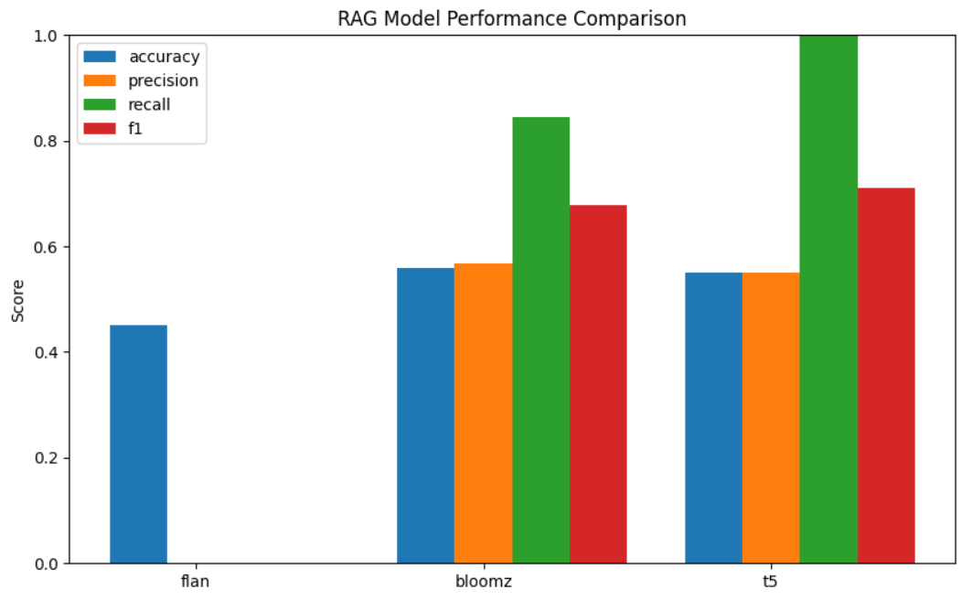
Figure 1: RAG Model Performance Comparison across Flan-T5-Small, T5-Small, and Bloomz-560M on the PubMedQA test set.
Analysis of Results:
- Flan-T5-Small: Despite strong instruction tuning, Flan-T5 showed very low precision and recall. This indicates misalignment between the retrieved evidence and model output, suggesting that small instruction-tuned models may struggle with highly specialized biomedical reasoning when context is complex.
- T5-Small: Achieved perfect recall but moderate precision, leading to a high F1-score. The model often defaulted to “yes” answers, inflating recall but generating false positives. Retrieval helped improve factual grounding but could not fully overcome instruction limitations.
- Bloomz-560M: Produced the most balanced performance with moderate precision and high recall. Its multilingual, instruction-tuned training enabled it to leverage retrieved context more reliably, though reasoning depth and domain-specific understanding were still limited.
Factual Accuracy and Reasoning Quality:
- Retrieval clearly improved grounding for all models, reducing hallucinations and encouraging evidence-based reasoning.
- T5-Small benefited most in terms of recall, Bloomz provided the best balance, and Flan-T5-Small struggled to interpret multi-chunk context effectively.
- Errors primarily occurred when questions required integration of multiple evidence pieces or understanding subtle experimental outcomes.
Observations:
- Smaller LLMs can benefit from RAG, but instruction tuning and model architecture significantly affect the ability to reason over biomedical content.
- Balanced metrics (precision + recall) are crucial: high recall alone may inflate perceived performance but reduce answer reliability.

Discussion
Flan-T5 stands out for its consistent reliability and robustness, providing accurate yes/no answers across varied prompts, which makes it suitable for tasks requiring stable performance. Bloomz, on the other hand, generates richer reasoning and more elaborate explanations, making it ideal when interpretability or justification of answers is important, though it can sometimes overcomplicate or hallucinate. Vanilla T5 is less reliable without task-specific fine-tuning and may produce inconsistent or vague outputs, limiting its off-the-shelf usability. LLaMA-based models offer flexibility and adaptability but are highly sensitive to prompt phrasing and may require careful prompt engineering. Across all models, the quality and relevance of retrieved context significantly influence performance, with poor retrieval leading to incorrect or incomplete answers. Overall, model selection involves a trade-off between reliability, depth of reasoning, and sensitivity to input context.

Conclusion
Small language models demonstrate limited reasoning ability in the biomedical domain, often producing incomplete or inconsistent answers without task-specific adaptation. Incorporating a Retrieval-Augmented Generation (RAG) approach moderately improves performance by providing relevant contextual information, though gains are constrained by retrieval quality. Models like Flan-T5 show more stable results, while others, such as vanilla T5, require careful fine-tuning to achieve reliable outputs. Bloomz and similar reasoning-oriented models can generate richer explanations but remain sensitive to prompt design and domain specificity. Future work should explore domain-specific embeddings to enhance context understanding, task-specific fine-tuning to improve accuracy, and enhanced retrieval strategies to ensure high-quality evidence is incorporated. Overall, integrating these improvements could substantially increase performance of small models in biomedical question-answering tasks.

References
- Chung, H., et al. (2022) Scaling Instruction-Finetuned Language Models.
- Jin, Q., et al. (2019) Exploring the Limits of Transfer Learning with a Unified Text-to-Text Transformer.
- Karpukhin, V., Oguz, B., Min, S., Lewis, P., Wu, L., Edunov, S., Chen, D., & Yih, W.-t. (2020). Dense Passage Retrieval for Open-Domain Question Answering.
- Khattab, O., & Zaharia, M. (2020). ColBERT: Efficient and Effective Passage Search via Contextualized Late Interaction.
- Lewis, P., Oguz, B., Rinott, R., Riedel, S., & Stoyanov, V. (2020). Retrieval-Augmented Generation for Knowledge-Intensive NLP Tasks. NeurIPS 2020.
- Muennighoff, N., Raffel, C., & et al. (2022). Flan-T5: Instruction Fine-Tuned Text-to-Text Transformer.
- Reimers, N., & Gurevych, I. (2019). Sentence-BERT: Sentence Embeddings using Siamese BERT-Networks.

